6th Grade English Language Arts
Smoky Mountain Elementary School
2019-2020 Syllabus
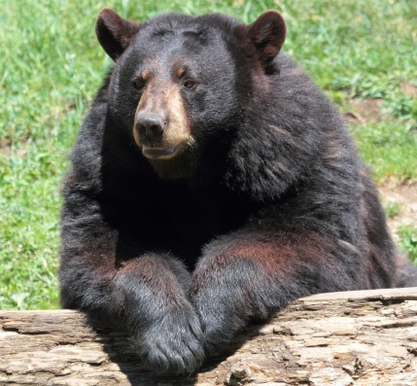
Welcome to 6th Grade!
6th grade ELA is a combination of the literacy skills: writing, thinking, speaking, reading, listening, and comprehending. This year we will once again strive to improve our writing, vocabulary, spelling, reading, punctuation, and grammar. Writing is a necessary skill that is used throughout life. We must continue to improve our word choice, fluency, sentence structure, paragraph development, and essays. ELA is the backbone of all our other subject areas. Reading and writing are the key to success!
Class Motto
I am a Smoky Bear. No, really I am a Smoky Bear. I attended Smoky Mountain Elementary School from K-8. I loved Smoky Mountain and I still do. I was a member of TAG and the Scholar’s Bowl. I was even a cheerleader too. You can be anything here too. Just work hard and give it your best. I am here for you and I believe in you.
Class Materials Needed
*1-Subject Spiral Notebooks (2)
*2-pocket folders no prongs (2)
*1 inch Standard Binder (2)
*Plenty of No.2 yellow pencils and pencil top erasers
Important Class Notes
*Each Monday a class newsletter will be sent home informing parents/guardians of upcoming events and assignments as well as current course of study.
*This year we will be using Google classroom to complete some assignments. Please be sure to return the student email permission for ASAP. These school emails will be used EXCLUSIVELY for schoolwork. When the classroom page is set up, it will be posted in the class newsletter.
*In addition we will be implementing AMPLIFY, a highly engaging and exciting ELA curriculum. Student and parental access links will be included in the class newsletter when they become available.
*Grades will be based on the following assignment types: homework, projects, quizzes, exams/tests, workbook, and reading/writing assignments. Grades will be posted to the ASPEN Grade Book.
*Make-Up Work should be completed as soon as possible. Please check with the teacher about missed work.
* We will be using the demerit system again this year, but please make good choices. Warnings, educational penalties, loss of rewards, call/note home to parents, or principal visit may be used. Positive behavior will be rewarded such as: recess at lunch, afternoon reward recess, concession stand, movie time (once in nine weeks), technology time, candy/prize box, and T-Kids.
Contact Information
Bobbie J. Stinson
Phone: (423)487-2255
E-Mail: stinsonb@cocke.k12.tn.us

Visit the link below to view the Tennessee State Learning Standards required for 6th grade ELA.
These will be taught throughout the academic school year.
https://www.tn.gov/education/instruction/academic-standards/english-language-arts-standards.html

6th Grade ELA
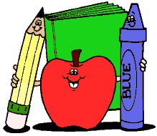
Course Calendar
Unit 1: Narrative Reading & Argumentative (Opinion) Writing

Anchor Text: Boy: Tales of Childhood by Roald Dahl

Objectives:
*Students will understand the impression of a moment.
*Students will observe how an author creates a character.
*Students will use the writing process and techniques to produce an opinion about who causes more trouble in the book: the boys or the adults? Cite evidence.

Major Assignments: Argumentative Essay, Reading Project

Unit 2: Scientific and Technical Texts and Informational Writing

Anchor Text: The Secret of the Yellow Death: A True Story of Medical Sleuthing by Suzanne Jurmain

Objectives:
*Students will read like an investigator of scientific and investigative sleuthing.
*Students will seek the truth about yellow fever.
*Students will write an informational essay about people that problem solve.
Cite evidence.

Major Assignments: Informational Essay, Reading Project, Informational Writing

Course Calendar Continued
Unit 3: Informational Essay and Argumentative Writing

Anchor Texts: Various informational articles concerning chocolate

Objectives:
*Students will read facts and stories about chocolate through the ages.
*Students will synthesize information from several sources to develop an argument.
*Students will complete scavenger hunts, debate, internet research, and a media project.
*Students will write an argumentative essay about whether chocolate should be included in school lunches. Cite evidence.

Major Assignments: Informational Essay, Scavenger Hunt, Debate, Media Project, and Argumentative Writing

Unit 4: Greek Mythology and Argumentative Writing

Anchor Text: Heroes, Gods, and Monsters of the Greek Myths by Bernard Evslin

Objectives:
*Students will explore three stories from Greek mythology: Prometheus, Odysseus, and Arachne.
*Students will consider the state of a single person concerning the role people play in the world and the various communities that they live.
*Students will write an essay arguing whether characters from two of these myths are destroyed by their pride. Cite evidence.

Major Assignments: Mythology Reading, Quest, Argumentative Writing

Course Calendar Continued
Unit 5: Aztec Mythology and Narrative Writing

Anchor Text: Summer of the Mariposas by Guadalupe Garcia McCall

Objectives:
*Students will read a novel about the journey of the Garza sisters.
*Students will learn how characters change and develop.
*Students will write a narrative essay about one of the heroes being successful.

Major Assignments: Aztec Mythology, Narrative Writing

Unit 6: TN Ready Review

Anchor Texts: Various Narrative, Opinion, and Informational Texts

Objectives:
*Students will analyze texts using learning standards taught throughout the year to practice and reinforce testing skills.

Major Assignments: TN Ready Test

Unit 7: Informational Essay and Narrative Writing

Anchor Texts: A Letter from Mary Lines

Objectives:
*Students will research to understand what happened with the Titanic.
*Students will learn the difference between primary, secondary, and tertiary sources. Also, if sources are reliable and ethical pieces of information to use.
*Students will write a narrative writing essay from the point of view of a passenger.

Major Assignments: Informational Essay, Research, Narrative Writing
Letter Grade Assignment
Letter Grade  A  B  C  D  F | Percentage  93-100%  85-92%  75-84%  70-74%  0-69% | Performance  Excellent  Good  Average  Poor  Failing

Attendance & Class Participation
Attendance is one of the important factors to a successful academic school year. Attendance is crucial to sixth grade success. Participation is another important factor to a successful academic school year. Please make every effort to be here and participate. It is very important to understand that this year the TN Ready test will count for at least 10% of your final semester grade. Your work all year long is so important and your work on this test requires your very best effort.

